Little SPARK: Simple Play Adaptations to Reference for Kids

Hand2Mind Express Your Feelings Sensory Bottles
Description: | Image:
Express Your Feelings Sensory Bottles are designed to help children identify and manage their feelings in a quiet, hands-on way. | 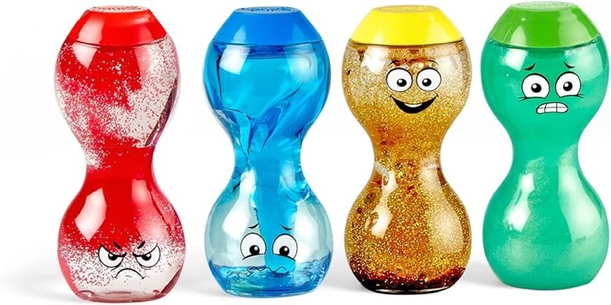

Who Might Benefit?
Those who are learning to manage strong emotions, regulate their behavior, and focus effectively, often benefit from quiet, self-directed activities and sensory supports throughout the day.

Why Use?
Provides an opportunity to talk about feelings, show how they are feeling without talking, explore self-regulation, and engage in quiet, self-calming activities.
Instructions for Use: | Adaptation Ideas:
Environmental Considerations  - Quiet, private area for discussing feelings.  Positioning & Alternate Positioning  - Use in any position where the bottles can be reached and viewed.  Basic Play/Use  - Shake, tip, or swirl the bottles and watch the contents move and settle.  Extended Play/Use  - Play color identification activities.  - Explore with a light box.  Play/Use with Others  - Play/sing the song “If You’re Happy and You Know It” and make up actions to go along with the feelings.  - Play a color matching game. | Build It Up  - Use Dycem or shelf liner to provide gripping surface.  Stabilize It & Contain It  - Use a shallow box or cylindrical holder for holding bottles upright and containing to one space.  Simplify It  - Introduce/use one at a time.  Add Sensory Cues  - Listen to quiet music while exploring bottles.  Communication Support  - Add visual supports.  - Read stories about different characters and their feelings.  Alternative Uses  - Use as a simple timer.  - Use in group activities like color matching, transition activities, story or circle time.

Words to Encourage Play/Use
I feel   | Happy | Sad
Sick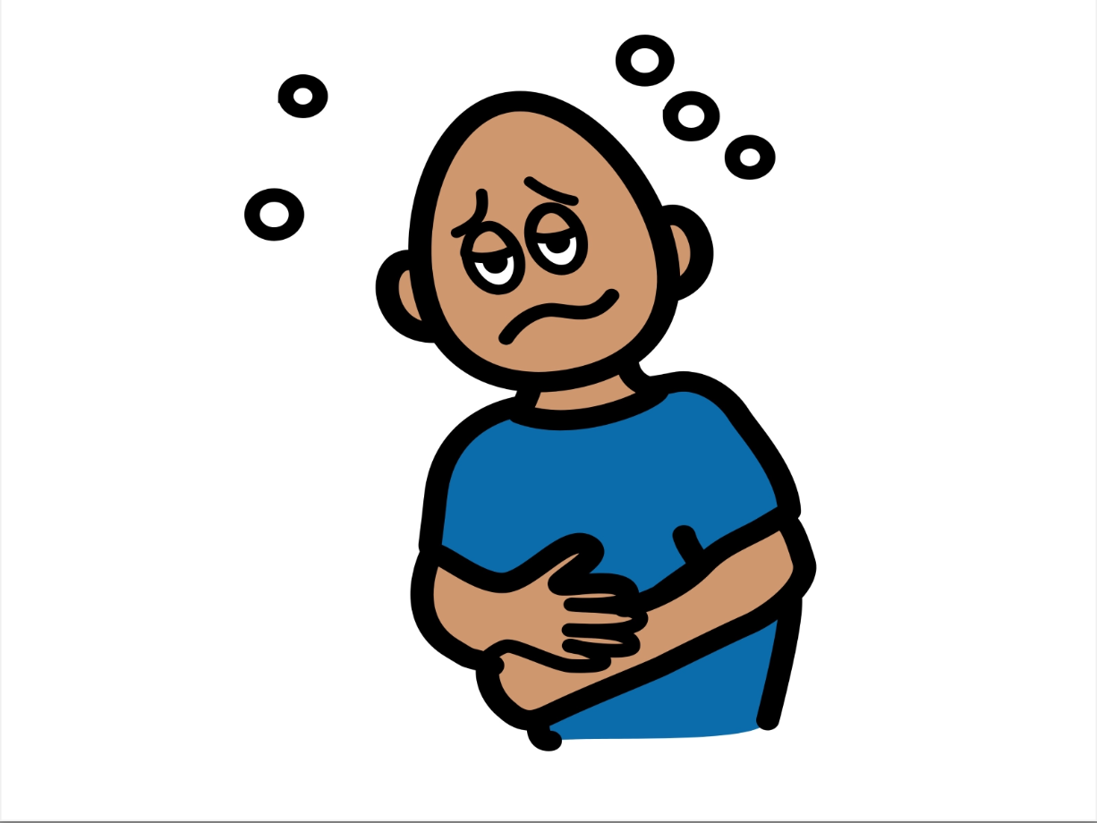 | Surprised | Tired 
Confused | Mad | Scared  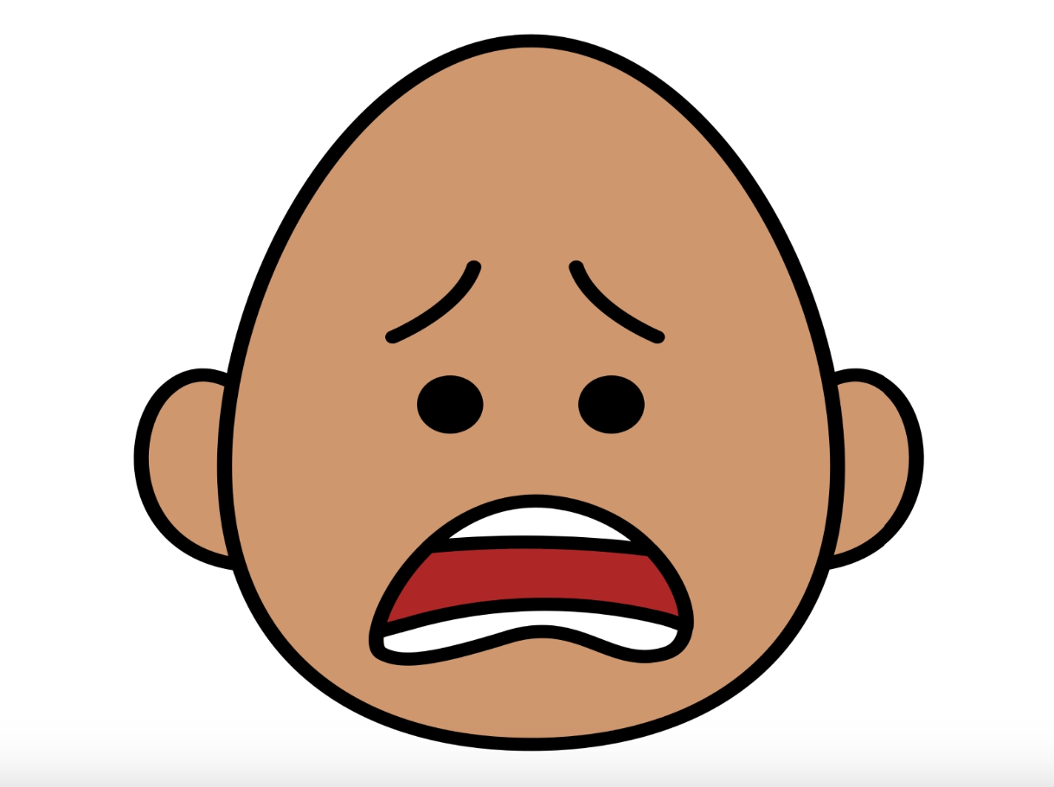
*”Adaptations” adapted from: Haugen’s Modes for Adapting Toys based on materials from the "Let's Play" Project at the University of Buffalo
PCS is a trademark of Tobii Dynavox, LLC. All rights reserved. Used with permission.

